Дата: 21.09.2023 Клас: 7-Б

Предмет: Англійська мова

Тема: Після школи

Мета: формувати навички вживання нових лексичних одиниць; удосконалювати навички аудіювання й усного мовлення з опорою на лексико-граматичні структури; розвивати мовну здогадку; виховувати доброзичливе ставлення до співрозмовника

Вчитель: Глуговська Л.Г.

**Хід уроку**

***1.Greeting***

Good afternoon, dear children! I’m glad to see you. Are you ready to start our lesson? Let’s start.

**2. Brain-storming:**

T: So! What can you do after the classes? Що ти робиш після уроків?

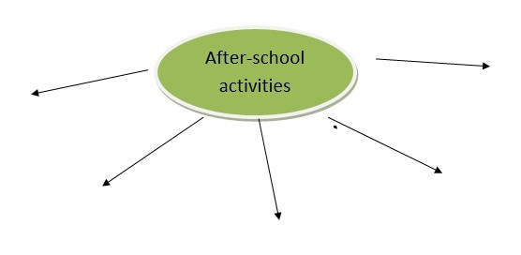

**3. Reading**

Read about children`s after-school activities and do the tasks below.

Прочитай текст про діяльність дітей після школи та виконай завдання.

TEXT

Helen.

Hello! I am keen on reading. I have got a big library at home. I prefer historical novels. Sometimes I go  to the cinema with my friends and watch screen versions of our favourite books. Then we share ideas about acting in the café.

Nick

I am crazy about sport. I am good at playing basketball. So, I joined school basketball team. We try out different tricks at our classes. Besides, I ride a bike in the park on Saturdays, it`s a real fun.

Christina

I am not sporty. I`m fond of playing boarding games. I am good at chess and droughts. But my favourite game is “Snakes and Ladders”. It is an old Indian game. My father brought it from India after his trip there.

Jasmine

My friends say that I am musical and romantic. I go to Music school. I am good at singing and playing the piano. I practice three hours a day. I always take part in school concerts. I want to be a famous singer in future.

**4. Speaking**

Answer the questions:

* Who likes boarding games?
* Who has got many books?
* Who go cycling at weekends?
* Whose father brought a present from other country?
* Who is a member of sports team?
* Who is good at playing the musical instrument?

**5. Listening**

Watch the video about « After School Activities And Programs For Kids»

<https://www.youtube.com/watch?v=V6QgSiPqBO0>

**6.Writing**

***Thursday, the twenty-first of September***

***Homework***

***Exercise 1 page 22***

З’єднай пари слів так, щоб утворились словосполучення.

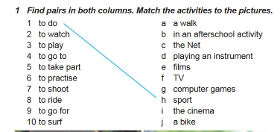

***7. Homework***

Домашнє завдання:

1. Опрацювати конспект, переглянути відео;

2. Виконати Exercise 1 page 22 (письмово).

**Надіслати виконане завдання на освітню платформу Human або на Viber (0964124047)– Людмила Григорівна.**